
ANALYSIS REPORT
COMP 258 - Assignment 2
Train and Use MLPs to solve various prediction problems

Wardatul Keskin | 301294696
Due Date : October 16th, 2025
Professor: Muhammad Saiful Islam

CENTENNIAL COLLEGE

Exercise 1: Backpropagation Algorithm

Introduction
The purpose of this lab was to design and implement a Multi-Layer Perceptron (MLP) network to classify iris flower species using the backpropagation algorithm.
This exercise aimed to deepen understanding of how MLPs learn through forward and backward propagation, how loss gradients guide weight updates, and how hyperparameters affect convergence.
The task involved:
- Applying data preprocessing (normalization, encoding) to prepare features for neural training.
- Implementing backpropagation manually based on the lab class without relying on high-level libraries.
- Training a small feed-forward neural network for multi-class classification of Iris Setosa, Iris Versicolor, and Iris Virginica.
- Evaluating model accuracy and visualizing the learning curve.

Experiment Setup

Data Preparation and Modelling
Dataset
The Iris dataset was used, containing 150 samples and four input features (sepal length, sepal width, petal length, and petal width). The data was split into 141 training samples and 12 testing samples, with equal class representation.

Data Preprocessing
- Label Encoding & One-Hot Encoding: Species were encoded into [1,0,0] for Setosa, [0,1,0] for Versicolor, and [0,0,1] for Virginica.
- Normalization: Min-Max scaling was applied to rescale features between 0 and 1 for faster convergence.
- Exploratory visualization using pairplots showed that Setosa was linearly separable, while Versicolor and Virginica overlapped — indicating the need for non-linear decision boundaries.
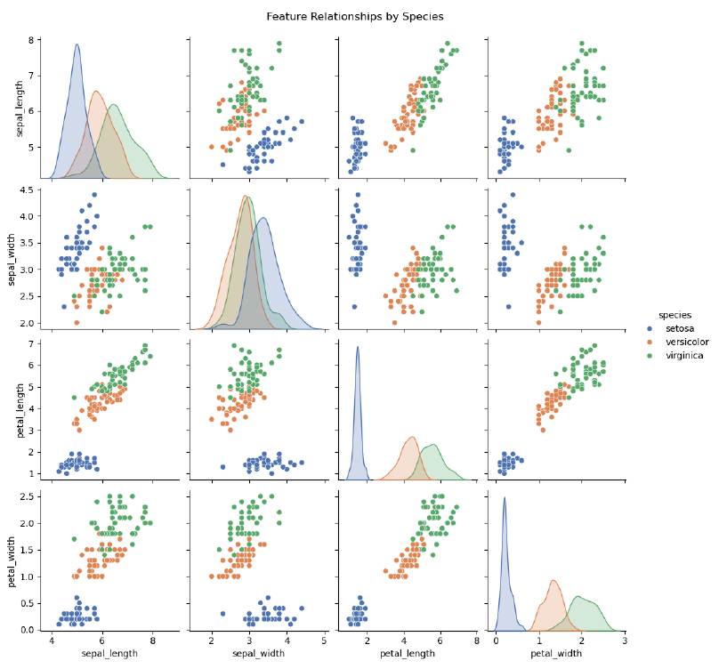
Figure 1. Plot of Feature Relationships by Species

Network Architecture
The implemented MLP followed this structure:
Table 1. MLP Architecture
Layer | Neurons | Activation
Input | 4 | –
Hidden | 5 | Sigmoid
Output | 3 | Softmax

Hyperparameters
Below are the hyperparameters used:
Table 2. Hyperparameters
Parameter | Value
Epochs | 2000
Learning Rate | 0.1
Loss Function | Cross-Entropy
Optimizer | Gradient Descent
Weight Initialization | Random Normal
Random Seed | 42

Implementation Details
- Forward propagation: Calculated hidden activations using the sigmoid function and output probabilities using softmax.
- Backward propagation: Computed gradients of weights and biases with respect to the loss function and updated them via gradient descent.
- All computations were implemented manually, emphasizing understanding of matrix operations in neural networks.

Results
Training Performance
The model showed smooth convergence as the loss decreased steadily throughout training:

Table 3. Output layers using Softmax Probabilities
Epoch | Cross-Entropy Loss
0 | 1.0986
500 | 1.0865
1000 | 0.5931
1500 | 0.3836
1900 | 0.3015

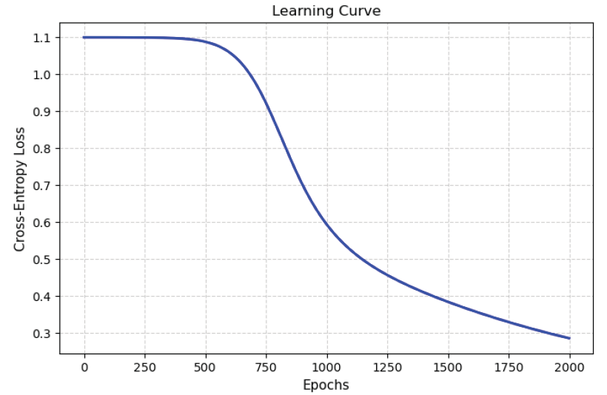
Figure 2. Learning Curve
The learning curve confirmed consistent learning without oscillations or divergence.
Accuracy
Table 4. Accuracy Results
Metric | Accuracy
Training Accuracy | 96.45%
Testing Accuracy | 100.00%

All test samples were correctly classified into their respective species, indicating strong generalization despite the small dataset.
Table 5. Test Classification Results
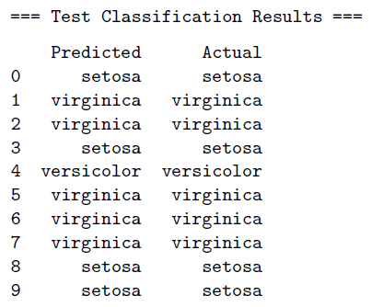
Output Observations
- Hidden layer activations showed diverse neuron responses, indicating good feature abstraction.
- Output softmax probabilities were highly confident for correct classes (e.g., [0.95, 0.05, 0.00] for Setosa).
- The model effectively learned non-linear boundaries between Versicolor and Virginica, which are otherwise overlapping in raw feature space.

Discussion and Conclusion
- The combination of Sigmoid + Softmax activations worked well for this small dataset.
- Cross-Entropy Loss was the appropriate objective for multi-class classification.
- A learning rate of 0.1 provided a good trade-off between convergence speed and stability.
- Further optimization could involve experimenting with ReLU activation and advanced techniques (optimizer and adaptive learning rate) for larger datasets.
Overall, the model achieved excellent performance and demonstrated how backpropagation enables neural networks to learn complex relationships between input features and target classes.
This lab reinforced both the theoretical and practical understanding of neural network training, gradient computation, and the importance of hyperparameter tuning.

Lesson Learned
- Proper data preprocessing (normalization and encoding) is essential for effective learning and convergence.
- Implementing the backpropagation algorithm manually deepened understanding of how gradients flow and how errors propagate backward through the network.
- The choice of architecture and learning rate significantly impacts model performance.
- a simple MLP architecture (4–5–3) can achieve high accuracy when trained carefully.
- Visualization of learning curves and feature distributions helps interpret both model learning and data complexity.

References
Goodfellow, I., Bengio, Y., & Courville, A. (2016). Deep Learning. MIT Press.
Nielsen, M. A. (2015). Neural Networks and Deep Learning. Determination Press.
Lecture Slides – COMP258 Neural Networks, Centennial College.

Exercise 2: MLP Training Using Backpropagation for CIFAR10 dataset

Introduction
The purpose of this lab is to design and implement Multi-Layer Perceptron (MLP) networks to classify images from the CIFAR-10 dataset using the backpropagation algorithm implemented in TensorFlow.
Through this experiment, the goal was to:
- Understand the use of backpropagation in training deep neural networks.
- Practice building and tuning MLP architectures using TensorFlow’s Sequential API.
- Explore how hyperparameters such as the number of hidden layers, activation functions, learning rates, and batch sizes affect classification accuracy.
The CIFAR-10 dataset consists of 60,000 32×32 color images across 10 classes (airplane, automobile, bird, cat, deer, dog, frog, horse, ship, truck). Each image belongs to one of these categories.

Experiment Setup

Data Preparation and Modelling
Dataset
- Training samples: 50,000 images
- Testing samples: 10,000 images
- Classes: 10 categories
- Input dimension: 32 × 32 × 3 = 3072 pixels per image
- Preprocessing: Normalized pixel values to [0, 1] and converted labels to one-hot encoded vectors.
Network Architecture
The baseline architecture used:
Table 6. Baseline Architecture
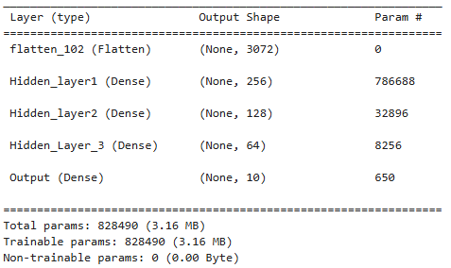
It was compiled with the Adam optimizer (learning rate = 0.001) and categorical crossentropy as the loss function, which is suitable for multi-class classification. This setup served as the baseline configuration before experimenting with other architectures and parameters. It’s also used the
Then several configurations were tested by varying:
- Number of hidden layers and neurons: 2 hidden layers (256, 128) and 3 hidden layers (256, 128, 64)
- Activation functions: ReLU, tanh, and sigmoid
- Optimizers: Adam, RMSprop, and SGD
- Learning rates: 0.01, 0.001, 0.0001
- Batch sizes: 64 and 128.
All experimental models were trained for 20 epochs, while the baseline model underwent training for 200 epochs, with test accuracy tracked throughout. To mitigate overfitting and preserve the most effective model, training incorporated EarlyStopping (monitor='val_accuracy', patience=10, restore_best_weights=True) and ModelCheckpoint (monitor='val_accuracy', save_best_only=True).

Results
Baseline Model
- Test Accuracy: 50.35%
- Test Loss: 1.5300
- Classification output for first 10 samples
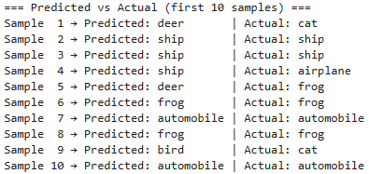
Figure 3. Result of first 10 Classification Output in Baseline Model
- Loss and Accuracy Curves
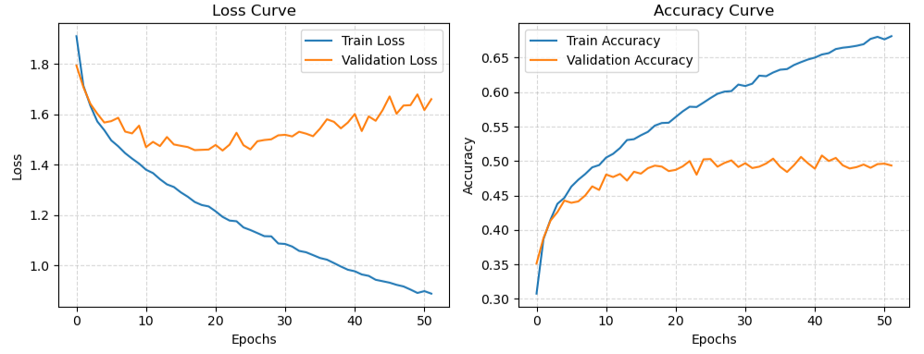
Figure 4. Loss and Accuravy Curves in Baseline Model

Experimental Results
- Below are the accuracy results of top 10 configurations
Table 7. Accuracy of top 10 Experimental Configuration
Accuracy | Optimizer | Layers | Activation | Learning Rate | Batch Size | Architecture
52.58% | SGD | 2 | tanh | 0.01 | 128 | (256, 128)
51.47% | SGD | 3 | tanh | 0.01 | 128 | (256, 128, 64)
51.26% | SGD | 3 | relu | 0.01 | 128 | (256, 128, 64)
50.92% | SGD | 3 | tanh | 0.001 | 64 | (256, 128, 64)
50.61% | SGD | 3 | relu | 0.01 | 128 | (256, 128, 64)
50.53% | SGD | 3 | tanh | 0.001 | 64 | (256, 128, 64)
50.46% | SGD | 2 | relu | 0.001 | 128 | (256, 128)
50.42% | SGD | 2 | relu | 0.001 | 64 | (256, 128)
50.16% | SGD | 3 | relu | 0.001 | 64 | (256, 128, 64)
49.96% | SGD | 3 | tanh | 0.01 | 128 | (256, 128, 64)

- Classification output of the best configuration
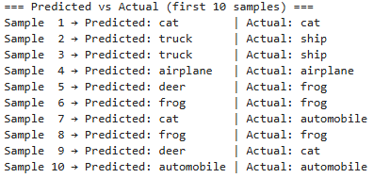
Figure 5. Predicted and Actual Output of first 10 Samples in Best Configuration
- Loss and Accuracy Curves of the best configuration
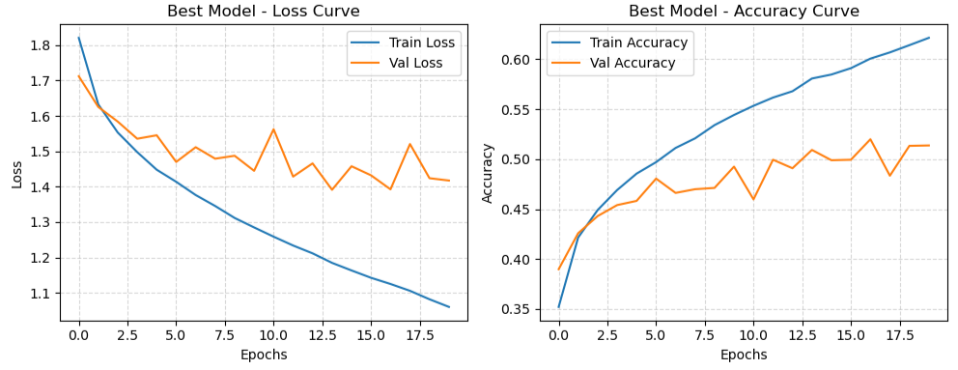
Figure 6. Loss and Accuracy of Best Configuration

Discussion and Conclusion
The baseline MLP achieved 50.35% accuracy using two hidden layers (512 and 256 neurons), ReLU activations, and the Adam optimizer with a learning rate of 0.001.
After experimenting with various hyperparameters, the best configuration reached 52.58% accuracy using the SGD optimizer, two hidden layers (256 and 128 neurons), tanh activation, learning rate 0.01, and batch size 128.
The improvement of about 2% can be explained by the combined effects of architectural and algorithmic factors:
- Optimizer:
- According to Lecture 5, Adam provides fast convergence by adaptively tuning learning rates, but it can sometimes over-adapt, causing oscillations or suboptimal minima for complex datasets like CIFAR-10.
- SGD with a slightly higher learning rate (0.01) and fixed update rule provided more stable generalization. This agrees with the theory that SGD may converge slower but can reach flatter minima, often improving test accuracy.
- Activation Function (tanh vs ReLU):
- The tanh activation, as covered in Lecture 2 (Defining Activation Functions – tanh), outputs values in the range [-1, 1], keeping activations zero-centered and allowing smoother radient flow.
- ReLU, while faster, may cause “dead neurons” where gradients vanish for negative inputs. On CIFAR-10, which contains both positive and negative feature patterns, tanh helped maintain learning activity across layers.
- Network Depth and Architecture:
- The best model used two hidden layers with moderate neuron counts (256, 128). As described in Lecture 5 (Fine-Tuning Neural Network Hyperparameters), shallow architectures are often sufficient for moderately complex data and less prone to vanishing/exploding gradients compared with deeper networks.
- Adding more layers beyond this (3–4 layers) did not improve performance and sometimes reduced validation accuracy, likely due to gradient instability and overfitting.
- Learning Rate and Batch Size:
- A learning rate of 0.01 helped SGD perform faster updates and escape small local minima.
- The batch size 128 balanced training stability and gradient noise, consistent with the theory that moderate batch sizes produce smoother convergence (Lecture 5 – Gradient Descent with Mini-Batches).
- Callbacks (EarlyStopping & ModelCheckpoint):
- Using EarlyStopping and ModelCheckpoint prevented overfitting by halting training when validation accuracy plateaued and saving the best model weights.
Despite these optimizations, the overall accuracy remained around 52–53%, which is relatively low for CIFAR-10.
This limitation arises because MLPs treat pixels independently, ignoring the spatial structure in images. As discussed in the course, MLPs are fully connected and not translation-invariant, they lack convolutional feature extraction, leading to weaker representation learning for images. Convolutional Neural Networks (CNNs) are typically used for such data, achieving >80% accuracy due to local receptive fields and parameter sharing.

Lesson Learned
- Learned how to design and train MLPs using TensorFlow’s Sequential API, including reprocessing, compiling, training, and evaluating models.
- Understood how backpropagation updates weights through gradient descent and how optimizers like Adam and SGD differ in convergence behaviour.
- Observed the impact of activation functions (ReLU vs. tanh) on gradient flow and learning stability.
- Gained experience in hyperparameter tuning, adjusting learning rate, batch size, and architecture depth to improve generalization.
- Discovered the importance of regularization techniques like EarlyStopping and checkpoints for preventing overfitting.
- Recognized that MLPs have structural limits for image tasks, leading to the exploration of CNNs as a more suitable architecture.
- Strengthened practical understanding of how theoretical lecture concepts (gradient descent, activation choice, optimizer behaviour, vanishing gradients) translate into real training outcomes.

References
Goodfellow, I., Bengio, Y., & Courville, A. (2016). Deep learning. MIT Press. https://www.deeplearningbook.org/
Nielsen, M. A. (2019). Neural networks and deep learning. Determination Press. http://neuralnetworksanddeeplearning.com/
Géron, A. (2019). Hands-On machine learning with Scikit-Learn, Keras, and TensorFlow (2nd ed.). O’Reilly Media.
Fausett, L. V. (1994). Fundamentals of neural networks: Architectures, algorithms, and applications. Prentice-Hall.
Rojas, R. (1996). Neural networks: A systematic introduction. Springer.
Toronto University. (n.d.). CIFAR-10 dataset. Retrieved from http://www.cs.toronto.edu/~kriz/cifar.html
Centennial College. (2021). COMP-258: Neural networks – Lecture 2: Multilayer Perceptrons (MLPs); Lecture 5: Training Deep Neural Networks. Centennial College Course Materials.
TensorFlow. (2024). Keras API reference. TensorFlow. https://www.tensorflow.org/api_docs/python/tf/keras

